HIGH-PERFORMANCE QUASI-Z-SOURCE SERIES RESONANT DC–DC CONVERTER FOR PHOTOVOLTAIC MODULE-LEVEL POWER ELECTRONICS APPLICATIONS
ABSTRACT
This paper presents the high-performance quasi-Zsource series resonant dc–dc converter as a candidate topology for the photovoltaic module-level power electronics applications. The converter features a wide input voltage and load regulation range thanks to the multimode operation, i.e., when the shoot-through pulse width modulation and phase-shift modulation are combined in a single switching stage to realize the boost and buck operating modes, respectively. Our experiments confirmed that the proposed converter is capable of ensuring ripple-free 400 V output voltage within the sixfold variation of the input voltage (from 10 to 60 V). The converter prototype assembled achieved a maximum efficiency of 97.4%, which includes the auxiliary power and control system losses.

BLOCK DIAGRAM FOR PROPOSED SYSTEM
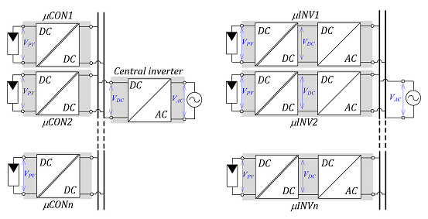
Fig. 1. Full-power converters for the parallel connection of PV modules: microconverters (μCON) with (a) common dc bus and microinverters (μINV) with (b) grid-side connection.
DESIGNG SOFTWARE AND TOOLS:
MAT LAB /SIMULATION Software and simu power systems tools are used. Mainly control system tools, power electronics and electrical elements tools are used.

